Homemade Watering Can

You will need:
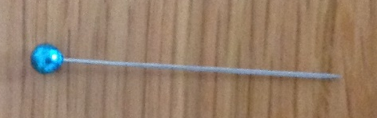 | A pin
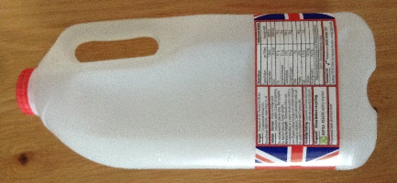 | A milk container
Instructions:
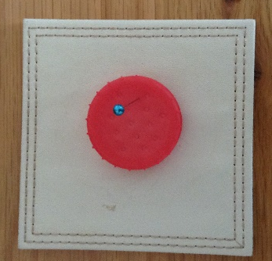 | Remove the lid and make holes in it using the pin. I find that the water flows better if you make the holes slightly larger by wiggling the pins around after pushing it through the lid.
Top tips: | Put a cloth or mat under the lid when pushing the pin through to protect your working surfaces from getting scratched.
 | Use different sized containers for different people i.e. 1pint containers for small children or the those who find it hard to lift heavier ones.
 | Varying the size of the holes will vary the flow of water.

Go and have a go.

