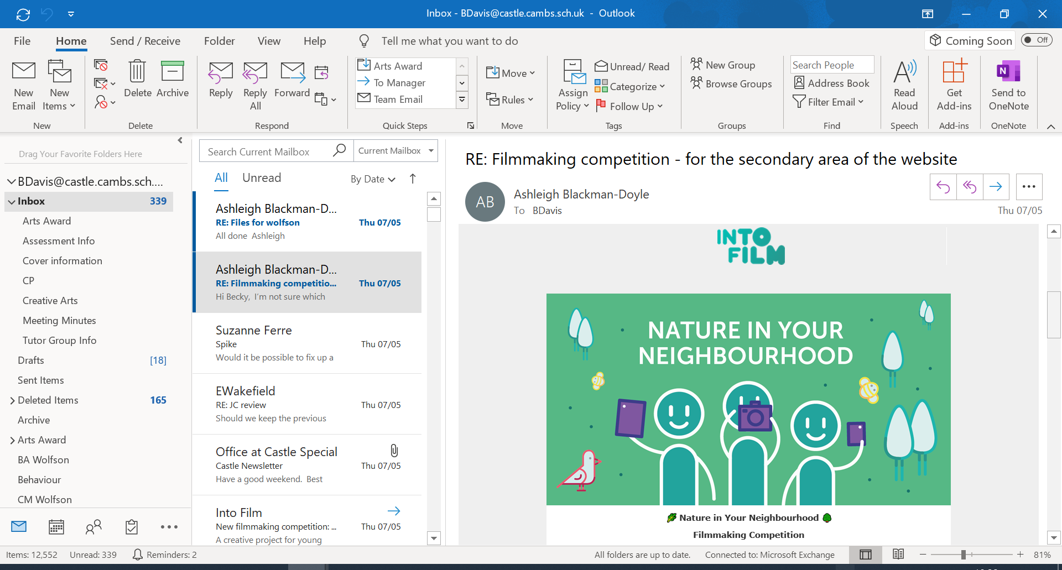
Intofilm have announce their new filmmaking competition, specially created to help children make the most of their time during lockdown.
Nature in Your Neighbourhood offers a fulfilling and creative project that young people aged 5 to 19 can complete within their schools or homes - plus a chance to win fantastic prizes including filmmaking equipment.
How it works
They’re asking young filmmakers to celebrate their surroundings by creating a 3-5 minute live-action or animated short that documents something they’ve noticed or appreciated while spending more time in their local area. Whether it’s a school playground, local park or even a view from the window. Shorts can be shot using mobile phones, tablets or cameras, and their handy filmmaking resources are a great place to start. Films should be submitted online along with a completed entry form by the closing date of Friday 19 June.
See the full details for Nature in Your Neighbourhood

The makers of the winning film will receive a home filmmaking bundle worth £300, and two runners up will each get their hands on a year's subscription to Netflix.
See all details

Simple filmmaking guides
There are resources on live action filmmaking and stop-motion animation that will help young people get started.
Download the resources


