 |  |  |  |  |  |  |  |  |  |  | 
 | Rachel |  | Colin |  | Ellie |  | Chris |  | Zaida |  | Javier
 |  |  |  |  |  |  |  |  |  |  | 
 | Kevin |  | Sainty |  | Sarah |  | Clare |  | Nicola |  | Pete
 |  |  |  |  |  |  |  |  |  |  | 
 | Jez |  | Laura |  | Mario |  | Ana |  | Andrew |  | Chloe
 |  |  |  |  |  |  |  |  |  |  | 
 | Gary |  | Anthony |  | Sweety |  | Terry |  | Meg |  | Rav

 | Rav |  | Mario |  | Chloe |  | Jez |  | Ana |  | Kevin
 | Colin |  | Sweety |  | Chris |  | Ellie |  | Gary |  | Meg
 | Nicola |  | Javier |  | Zaida |  | Sainty |  | Anthony |  | Terry
 | Clare |  | Pete |  | Sarah |  | Andrew |  | Laura |  | Rachel

 |  |  |  |  |  |  |  | 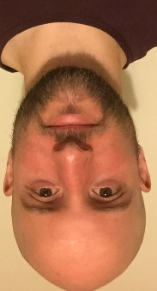 |  | 
Chris |  | Terry |  | Pete |  | Rav |  | Javier |  | Gary
 |  |  |  |  |  |  |  | 
Andrew |  | Jez |  | Kevin |  | Mario |  | Anthony |  | Colin
 |  |  |  |  |  |  |  |  |  | 
Zaida |  | Sarah |  | Laura |  | Sweety |  | Sainty |  | Ellie
 |  |  |  |  |  |  |  | 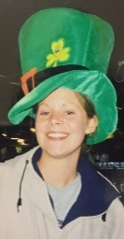 |  | 
Rachel |  | Meg |  | Clare |  | Nicola |  | Chloe |  | Ana

Chris |  | Terry |  | Pete |  | Rav |  | Javier |  | Gary
Andrew |  | Jez |  | Kevin |  | Mario |  | Anthony |  | Colin
 |  |  |  |  |  |  |  | 
Zaida |  | Sarah |  | Laura |  | Sweety |  | Sainty |  | Ellie
Rachel |  | Meg |  | Clare |  | Nicola |  | Chloe |  | Ana

Instructions:
- Print out 1 copy of each of these. 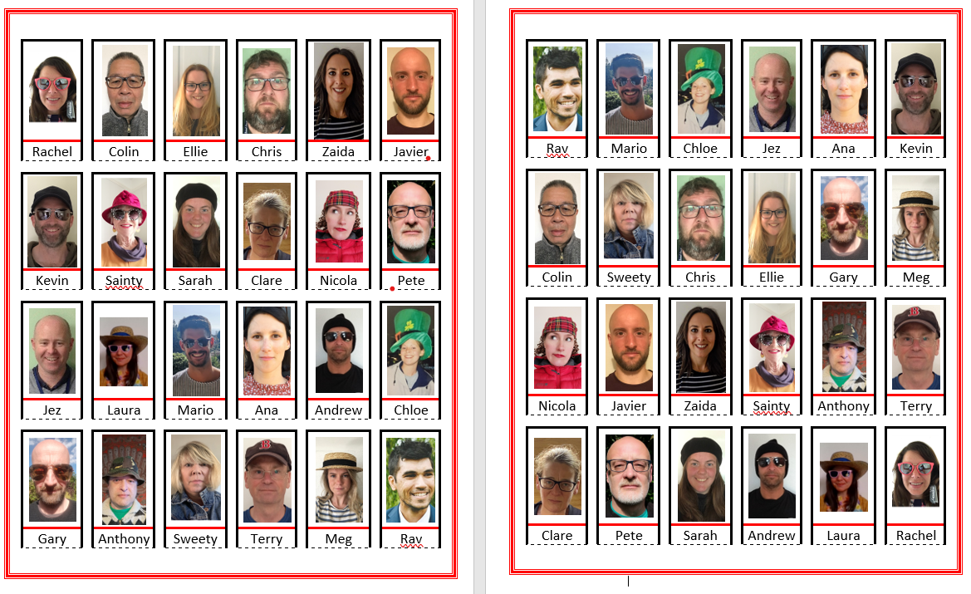
- Stick them onto a piece of cardboard.
- Using a craft knife or a sharp pair of scissors cut along the dark black lines around each picture, be careful not to cut along the red lines or the black dotted lines.
- The faces with the names can now be folded upwards along the dotted lines.

- Print out 2 copies of each of this.
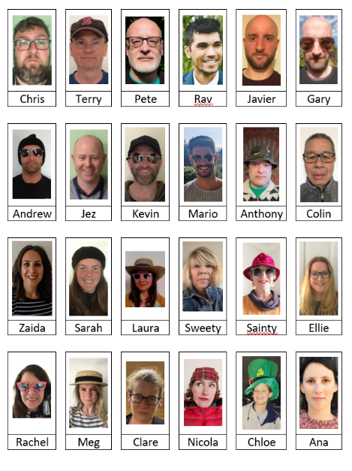
- Stick both copies onto cardboard.
- Cut out each picture around the black lines remember to leave the name
- One set per player.

Rules of the Game
Guess Who is a two-player game where players use yes or no questions to find the hidden character of their opponent. The first player to guess the other player’s hidden character wins.

Each player takes their game board of 24 faces and lifts each face up so that their opponent does not see their board. Each player also picks one card out of their pack. This card represents the character your opponent must guess and the character you must answer questions about.
The youngest player goes first, beginning by asking the other player a characteristic found on one of their 24 visible characters (both players have the same 24 tiles). Example: “Does your character have brown hair?”
If they say, “yes,” the asking player flips over all the characters without brown hair. If they say, “no,” the asking player flips over the characters that have brown hair. Through the process of elimination, players will eventually be able to “guess” the name of their opponents’ character.

Each player gets one yes or no question per turn and may only guess (to win the game) once per game. If a player successfully guesses their opponents hidden character, then they win; if their guess is wrong then they lose.

