Pembroke Timetable Overview 26-27

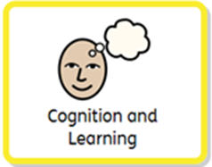 | Sensory story and associated sounds  Attention Building  Maths in Stories  Mark making  Cause and Effect/  Switch Skills  Interventions:  Living Paintings | Pembroke class are pre – formal learners. Our classroom is lively and full of fun as we learn together through a range of different activities and experiences. Our lessons are sensory and communication based which helps meet the needs of our children with multisensory disabilities.  For learning to take place, our learners must be comfortable, relaxed and ‘ready to learn’. Positional changes happen frequently, with a minimum of two positional changes to be built into the timetable each day. This is made more fun by using Sensology sessions to frame the session with fun music and stretching and moving positions. Sensology is an educational approach emphasising sensory stimulation. It covers the five basic senses (see, hear, touch, smell, taste) but also the movement- related sensory systems: the vestibular (balance, head movements and gravity) and the proprioceptive (body positions, body mapping and planning movements).  Pupils experience familiar stories in our sensory story sessions. These sessions focus on the students working on their understanding of the world around them. Using cause and effect switches, independently exploring objects and textures, using their senses to listen, look, smell and taste and anticipating familiar routines.  Throughout the day, pupils have the opportunity to develop their vision skills through light box work, tracking activities, navigating the school, eye pointing activities, photo work (covering the Core Areas of Sensory & Cognitive Skills, Communication, Physical Development).  Attention Building, anticipation and sustaining attention are embedded within sessions from our sensory stories to sensology sessions.
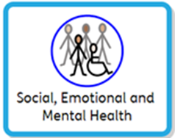 | Cueing the day  Meal times  Circle time  Creativity  Social games  Extra-curricular activities  Birthday celebrations  Preparing for adulthood  Interventions:  Attention Building  Music therapy  Touch and Groove  Creativity  Sensory Story  Mark making  Interactive Music  Soundbeam  Community Awareness and Inclusion Activities  Sensology  Community visits | These sessions are embedded naturally into our timetable, through activities such as Touch and Groove (emphasising consent), to snack, and lunch time (health and wellbeing). The repetitive structure of the sessions (and throughout the timetable) allows pupils to anticipate and take part in each routine, such as snack or personal care, as independently as possible.  Creativity is taught through interactive music and sensory art experiences. We also have a weekly, explorative music sessions where pupils are able to communicate choices between instruments, experience the vibrations of sound, and draw on the differences in volume and tempo.  Pupils have the opportunity to explore their world through accessing different areas inside and outside school as well as during community outings.
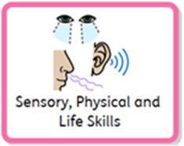 | Positional Changes  Physiotherapy  Hydrotherapy  Cycling  Outdoor exploration:  Playground  Courtyard  Work Experience  Intervention  Touch and Groove  Rebound therapy | Lessons and interventions ensure pupils have a change position every 2 hours. They also have weekly swimming and rebound activities to maintain as much physical movement as possible. When in different positions, pupils carry out bespoke lessons which will help them to develop core skills.  Pupils also work on using their vision throughout all activities, to reinforce visual skills they might find difficult.  Our pupils also use their standing frames, walkers, bikes and Acheever workstations where appropriate through the day.
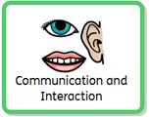 | Sensory story  Time sensology  Call and Response  Circle time  Interventions:  Intensive interaction is embedded throughout  Resonance Board  Soundbeam  Preparation for Adulthood  Outdoor Exploration  Community visits Assembly  Work Experience | Communication is an intrinsic part of everything we do so it is also built into all our other lessons and experiences, all our interactions and learning flows from Intensive Interaction.  To enable this, pupils are offered a variety of communication aids and methods to help their expressive language. From Big Mack switches to simple symbol use, on-body signing and object cues.  When planning communication sessions, we look for exciting and motivating activities that will inspire the children to engage, express themselves, make choices and begin to use functional communication.  Pupils are learning to develop their responses to routines and changes and  building their tolerance of unfamiliar environments/people. To support this, we are learning to accept a gradually increasing repertoire of object cues and onbody signing to support pupils’ understanding in new and unfamiliar routines and places. Alongside structured work experience activities within school and at a local farm.

