Bees Timetable Overview 26-27

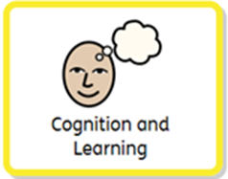 | Sensory story  Environmental sounds  Early phonic experiences  Attention Building  Maths in Stories  Mark making  Cause and Effect  Switch Skills  Rhyme through music  Number songs and early counting.  Tactile books  Switch controlled books | Attention building activities such as bucket motivate students to extend their attention, develop new ways to express themselves and ask for more, practise skills such as tracking lights or sounds or work on their reaching and grasping skills. It is also a great way to assess a child’s ability to engage by offering highly exciting items for them to explore.  Understanding how your actions have an effect on the world around you is an important building block for all future learning. We teach this skills through a variety of fun and exciting activities that are individualised to each child to make them as motivating as possible. Switch adapted toys, switch controlled games on the board, musical instruments, art activities, apps on tablet, marking making and sensory games all offer the children opportunities to practise this skill. Some children may prefer to experience a variety of these activities while others will need longer to process and learn the skills needed for one or two toys/games.  We support a child to access books and stories in a variety of ways. Our weekly sensory story is chance for the whole group to come together and enjoy a familiar story, they will have consistent multisensory cues for different parts of the story and contribute their voice using recordable buttons with repeated refrains.  It is also important to offer opportunities for more child directed exploration of books. Tactile or noisy books, switch controlled books and stories, living paintings and audio books are all used in the classroom to help with this.
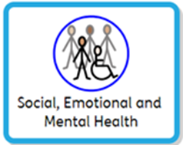 | Cueing the day  Meal times  Circle time  Art  Social games  Extra-curricular activities  Birthday celebrations  Sense-ology  Community visits  Music therapy  Sensory assembly  Turn taking activities  1:1 adult supported peer interactions. | Developing a sense of “who I am” and “what I like” is the first step to good emotional and mental health. We build in choice making to all of our activities throughout the day so we can see how the children express their preferences.  Social interaction between the children is encourage and supported by adults during all activities including creating time to allow students to interact with their peers 1:1.  Managing unpredictable or unfamiliar environments is an important life skill and community visits allow the children to do this whether it is a walk to the local library or a bus trip to the farm there are lots of benefits to getting out of the classroom. Being in the community offers opportunities for supported social interactions such as participating in checking a book out from the library.
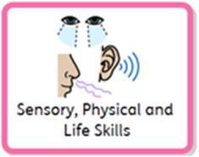 | Positional Changes  Physiotherapy  Hydrotherapy  Cycling  Rebound  Vision activities  Sense-ology  Outdoor exploration:  Playground  Courtyard | Lessons and interventions ensure pupils have a change position every 2 hours. They also have weekly swimming and rebound activities to maintain as much physical movement as possible. When in different positions, pupils carry out bespoke lessons which will help them to develop core skills. Pupils also work on using their vision throughout all activities, to reinforce visual skills they might find difficult. Our pupils also use their standing frames, walkers, bikes and Achiever workstations where appropriate through the day.
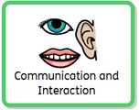 | Circle time  Choice making  Call and Response  Intensive interaction  Resonance board  Sound beam | Communication is an intrinsic part of everything we do so it is also built into all our other lessons and experiences, all our interactions and learning flows from Intensive Interaction. The adults in the room are highly in tune with the students responding to even small changes in behaviour, that might indicate preferences or expressive communication, to help students learn that their voice matter and is being listened to.  Pupils are offered a variety of communication aids and methods to help their expressive language to develop. From Big Mack switches to simple symbol use. We also support a child’s receptive language through on-body signing, object cues and symbols/signs.  When planning communication sessions, we look for exciting and motivating activities that will inspire the children to engage, express themselves, make choices and begin to use functional communication.

