Dragonflies Timetable Overview 26-27

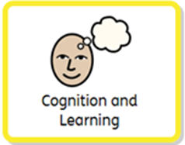 | Early literacy & numeracy concepts are introduced and explored through play-based activities throughout the day. We support all children to lay a strong mathematical foundation through play. In Wrens and Finches class this involves songs, stories, games, practical activities, and play. We encourage exploration with a sense of enjoyment.  Early literacy skills are based on children’s early skills from gesture, babbling, communication, talking and singing. Children in Wrens build upon their early mark making skills and developing writing using both gross and fine motor skills. We enjoy sensory stories, songs and rhymes in both group time and important and special 1:1 time. We develop decoding and reading for our “ready to read” learners.  Dragonflies are practicing pre-phonic awareness at stage 1 by developing attention and listening skills. We enjoy sensory stories in a group or 1.1 and are developing our awareness and interest in books. Books are available in the classroom every day in the classroom and the outside area. We have a daily session of reading in a calm and relaxed atmosphere where the students are encouraged to listen and join in. We practice early stages of phonics through songs, sounds and a focus on a ‘weekly’ phonic sound. Students are also provided with personalised books which reflect their interests to increase engagement. The students are exposed to letters and numbers on a daily basis, inside and outside the classroom. We set up activities in the outside area everyday which reflect our daily focus.
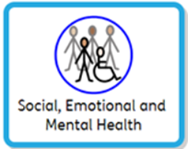 | In class we believe a child will thrive when they feel safe, valued, and feel like they belong. Personal and Social and Emotional Development is fundamental to all aspects of life. We place a high expectation on staff to support each pupil’s development based on where they are because this learning is key to children’s well-being and resilience. In Dragonflies we meet the needs of the individual so that the children can become more independent and form important friendships with both staff and peers. The teams use visual cues and Makaton signs to help transitioning throughout the day. We also use children’s individual preferred methods of communication (talker, PECS). The soft play area is used to allow the children with freedom of movement and when necessary, softplay is also a safe space for regulation and calming. Through the use of turn taking games, the students learn how to communicate and interact with their peers or adults.
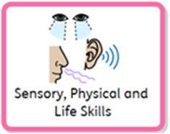 | Physical Development underpins all areas of the child’s learning and development. In Wrens and Finches class we provide an environment which enables extensive physical experiences. Health, wellbeing, and self-care are integral to physical development. Each child’s development relies on a whole-body experience, fine and gross motor control must happen together in an integrated way. Outdoor learning provides a well-planned focus on developing physical skills and links to the focus in each class for that day to the outside. The classes go to Forest School every day after lunch to support physical development and sensory exploration in an outdoor classroom. The students are given the opportunity to explore different nature elements. We also provide daily activities to support the daily focus while still relating to nature.  For those pupils who require sensory breaks, there are specific programmes, devised for each individual: these are used when needed and throughout the day. We plan weekly touch and taste and cooking sessions with seasonal ingredients and recipes to expose the students to a variety of different foods. They can explore textures, temperatures, flavours while also working on fine motor skills. For many students, this also works as a regulation and focus activity.  We also have multiple fine motor kills activities in the classroom daily, such as threading, cutting and mark making.  Developing our life skills and independence prepares us for adulthood. Dragonflies follow a daily structured routine which develop independence, life skills and emotional regulation. The class is exposed to important life tasks daily, such as washing hands before mealtimes and after toilet, hair brushing and toothbrushing stations and opportunities to experience different personal care items. The students are encouraged to participate in their daily self-care routines to encourage independence.
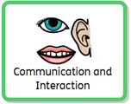 | From the moment the children arrive at school they are immersed in a language rich environment. Communication and Language lay a foundation for learning and development, it is closely intertwined with physical, social, and emotional experiences. The adults quickly tune in to the children’s way of communicating. In Dragonflies communication is at the heart of everything we do from the very start to end of the day, we believe every minute matters. Children are offered a variety of communication aids and methods to help their expressive language; we use Makaton signs alongside verbal language and symbols. By building strong relationships with our children we learn to read the pupils body language and can support them to use more formal means to use their voice through modelling. During snack time, each student has a personalised snack mat or their preferred communication aid. Communication boards are available for choosing time and lunch times and there are symbols both indoors and outside for pupils to be able to ask for things they want. At lunch time, every day, there is a symbolised daily menu provided for each table.

