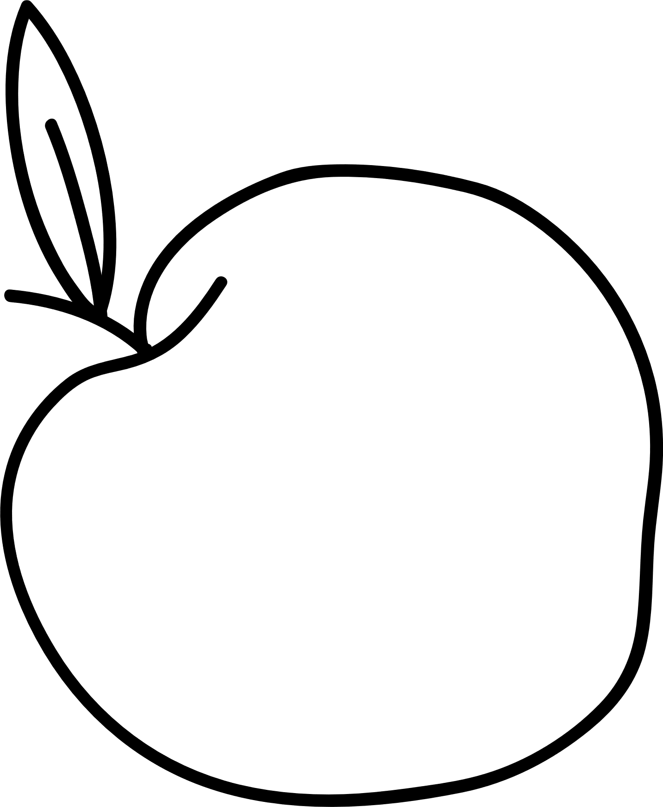

castle’s



Healthy Food

Pack



# Healthy Snack Ideas



* Fruit salad with yogurt and a broken up meringue – A healthy Eaton Mess. Yum!
* Apple slices dipped in Peanut Butter.
* Frozen fruit in yogurt – Creamy fruit lolly.
* Freeze your favourite drink in a lolly mould.
* Popcorn. You could even add your own flavour.

Other



|  |  |  |  |  |  |  |  |  |  |  |
| --- | --- | --- | --- | --- | --- | --- | --- | --- | --- | --- |
|  | Sweet Sweet |  |  |  | Veg Veg |  |  |  | Fruit Fruit |  |
|  |  |  |  |  |  |  |
| Chocolate | | |  | Veg sticks with | | |  | Fruit salad. | | |
| covered fruit. | | | humus. | | |  |  | Banana. |  |
| Banana muffin. | | | Sweet peas. | | |  | Fruit Kebab. | | |
|  | Fruit |  | Carrot sticks. | | |  | Apple slices. | | |
|  | smoothie. |  |  | Soup. |  |  |  | Fruit jelly. |  |

|  |
| --- |
|  |



# Wraps



All you need is your favourite sandwich fillings to create a wrap you you’ll love.

This is my favourite wrap with the ingredients I can find in my cupboards.

Ingredients:

1 large wrap (this would also work with a toasted Pitta bread)

1-2 slices of ham

Cheese

Coleslaw

Nandos medium sauce

Method:

I always cut my wrap in half so I have 2 semi circles. I can then make 2 small wraps.

Start with your sauce or wet ingredients so they can stick to your wrap.

1. Lay your wrap like a smiley face.
2. Spread the coleslaw in the middle

of the wrap and put a few drops of

Nandos sauce on.

1. Layer the cheese then the ham.
2. Fold the bottom up about 2 fingers up and then fold both sides in one at a time.
3. Enjoy!

# Smoothie



To create a tasty smoothie all you need is fruit and yogurt and maybe some honey or golden syrup.

This is what I had at home.

Ingredients:

1 banana

1 handful of chopped strawberries

4-6 tablespoons of natural or Greek yogurt

2 teaspoons of honey or golden syrup

Method:

In my blender I put all the ingredients in and give it a whizz. If you would like a colder smoothie, as long as your blender can blend ice, you could blend up a handful of ice cubes to make it like a slushy fruit smoothie.

Other fruit you could use could be:

Banana and blueberry

Blueberries and Strawberries

Raspberries and Strawberries

Enjoy!

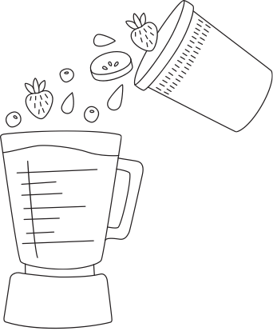



# Tasty Pasta

I love experimenting with different pasta recipes. To help give me inspiration I look in my fridge. I’m not the biggest fan of vegetables BUT I always manage to add veg in my pasta and it all goes.

This is my recipe, but you can always add ingredients if you have them or take some away.

Ingredients:

1 large cup of pasta

3 tomatoes (chopped)

2 tablespoons of tomato puree (or 2 tablespoons of ketchup)

¼ tin of sweetcorn

½ onion (chopped)

1 carrot (chopped)

Nandos sauce

Method:

1. Cook the pasta as per the instructions on the bag (ask an adult to help you here. You will need to use the hob which is really HOT)
2. In a medium sized saucepan (again ask an adult to make sure you are safe using doing this) put the sauces, chopped onion, chopped tomatoes, and chopped carrots. Stir the mixture until it is simmering.
3. When the pasta is cooked and drained by an adult, you can add the pasta into the saucepan and stir well until all the mixture is covering your pasta.
4. Enjoy!

